DEPARTMENT OF HOMELAND SECURITY
UNITED STATES COAST GUARD

SPECIFICATIONS
FOR

ELECTRIC VEHICLE CHARGING INFRASTRUCTURE:
BASE PORTSMOUTH

June 2020

Location:

USCG Base Portsmouth

4000 Coast Guard Blvd
Portsmouth, VA 23703

Summary:

The Coast Guard is soliciting construction of electric vehicle support equipment (EVSE) at Base Portsmouth. A total of seven (7) Level 2 dual port charging stations shall be installed, providing a total of twenty (14) charging ports capable of simultaneous operation. As part of this construction, the contractor is responsible for completion of all associated infrastructure upgrades necessary to support EVSE.

Data Capability Requirements Applicable To All Coast Guard EVSE:

EVSE shall be capable of:

  - Accepting payments from the General Service Agency (GSA) Fleet Wright Express, Inc (WEX) card for government fleet vehicles. Use of RFID cards and/or key fobs that bill individual WEX fleet fuel cards is permissible. No additional mobile app, web service, or credit cards may be required to enable government vehicle charging.

(Note: Instructions on becoming a WEX accepting merchant are available on the GSA website, https://www.gsa.gov/buying-selling/products-services/transportation-logistics-services/vehicle-leasing/fleet-services-card/vendor-information).

  - Capturing and relaying the following information to the government via an internet based dashboard/portal:
    - Energy consumption which can be broken down by vehicle or account,
    - Energy consumption by time of day,
    - Total number of charging sessions per day, and
    - Real time and historical availability of EVSE.

Construction Requirements:

I. Continuity of Facilities Operations: Schedule work to minimize interference with the facility’s normal operations. Normal operating hours are from 7:00 am to 4:00 pm Monday thru Friday except federal holidays. Any work during other hours shall be scheduled and approved with the Contracting Officer’s Representative and On-Site Representative a minimum of 48 hours in advance.
Contracting Officer’s Representative: LCDR Sarah Krolman
Base Portsmouth On-Site Representative: Mr. Thomas Jewett

II. Notification of Start and Completion of Work: The Contractor shall notify Coast Guard one week prior to start of work. Notification shall be given to the Contracting Officer, Contracting Officer’s Representative and On-Site Representative.

III. Safety: During the execution of this contract, the Contractor shall conform to the rules and regulations as set forth by OSHA Safety and Health Standards, 29 CFR Part 1926 - Safety and Health Regulations for Construction. The contractor shall have a written safety plan as required in FAR 5.236-13. The plan shall unequivocally assign responsibility and authority for safety to the superintendent by name. Immediate notification to the Contracting Officer’s Representative of lost time due to accidents is required. Provide two copies of workman’s compensation accident reports by noon of the day following the accident. The Coast Guard reserves the right to bar any workers or supervisors from the premises should they be documented as violating OSHA safety standards and regulations.

IV. Inspection: The Contracting Officer’s Representative has the right to reject defective workmanship or materials or work not performed as per the project specifications. Only the Contracting Officer or his/her representative may accept work performed by the contractor.

V. Operations and Storage: The contractor is to take whatever steps necessary to ensure that contractor materials are protected. The Coast Guard has no responsibility for receipt, storage, or protection of contractor materials. All equipment, materials and supplies shall be addressed to the contractor. The Coast Guard will not accept shipments. The contractor is responsible for the protection of existing structures, utilities, work and vegetation. Any damage shall be repaired at the contractor’s expense.

VI. Regulations Onboard Coast Guard Installations:
- Daily colors and the raising/lowering of the American flag will take place every morning at 8:00am and every evening at sunset. All personnel on Coast Guard property will face the main flagpole and maintain silence. All vehicles and equipment will halt during these brief events.
- The construction site shall be maintained in a clean condition at all times. This includes daily clean-ups of the construction and storage areas (FAR 52.236-12). The site shall be well lit and well barricaded/cordoned off as appropriate.
- No smoking is permitted outside designated smoking areas.
- All refuse disposal shall be done in accordance with federal, state, and local laws and regulations. All bulk waste shall be disposed of in contractor provided dumpsters.
- Traffic Regulations:
- No use of cell phones is permitted while driving vehicles or operating heavy machinery.
- All personnel shall obey all marked traffic signals including posted speed limits, stop signs, and stoplights.
- Absolutely no firearms or weapons of any kind are allowed onboard Coast Guard property.
- Notice shall be given to both the Contracting Officer’s Representative and the On-Site Representative 1 week in advance of any planned power, water, sewage, or lighting outages.
- The contractor shall provide a consolidated list of all contracted personnel including their drivers’ license numbers (or other valid government issued ID number) who will be working on Coast Guard property one week prior to the commencement of site work.
- Should warnings of gale force or stronger winds, or other inbound natural disasters be issued, the contractor shall take every practicable precaution to minimize the danger to persons, site work, and adjacent property. These precautions shall include closing all openings, removing loose materials, tools and equipment from exposed locations, and removing or securing scaffolding, field trailers, and other equipment or temporary work.
- No person other than the Contracting Officer has the authority to alter the terms of any contract or to issue any change orders.
- All contractor vehicles, equipment and gear onboard Coast Guard properties are subject to search at all times.
- Due to the dense nature of operations and support functions, all efforts within reason to minimize the size and footprint of the contractor’s lay down area shall be taken. Contractors shall carpool as much as possible to minimize the number of vehicles needing parking. At a minimum, the ratio of contractor employees to contractor vehicles shall be no less than 2:1.
VII: SCOPE OF WORK:

01 00 00 General Requirements

1.1 Contractor is responsible for all design, procurement, fabrication, site assessment, site preparation, construction, testing, and any other work necessary for the proper installation and commissioning of seven (7) AC level 2 dual port electric vehicle charging stations, providing fourteen (14) charging ports.

1.1.1 Many states and municipalities offer rebate programs for the installation of EVSE. The contractor is encouraged to complete corresponding applications and consider possible rebates when developing proposals.

1.1.2 Coast Guard offers no guarantee that rebate applications will be accepted. Primary use of infrastructure will be for government vehicles.

1.2 Contractor is responsible for applying for and obtaining applicable certifications, licenses, and permits necessary for the installation and operation of electric vehicle charging stations. All electrical work shall be performed by an electrical contractor licensed in the state where work is to be performed.

1.3 Contractor shall install, test, commission, and provide training for the electric vehicle charging stations. To ensure proper operation of equipment, the contractor shall oversee a test charge of a vehicle at each charger following installation. On-Site Representative may waive test charges if an electric vehicle is not available. Three (3) written copies of equipment operations and maintenance instructions shall be provided.

1.4 Charging stations shall be pedestal mounted and positioned to maximize the number of parking spaces served. Each dual port charging station shall serve two parking spaces.

1.4.1 Parking layouts should not to be altered to accommodate EVSE. Any parking layout modifications must be approved by the On-Site Representative and Contracting Officer’s Representative in advance.

1.4.2 All EVSE shall be installed as close as practicable to existing infrastructure capable of supporting electrical demand to prevent the need for extensive trenching and site repairs.

1.4.3 Charging station site configuration shall be coordinated with the unit On-Site Representative and provided for Contracting Officer’s Representative’s review and acceptance prior to installation. The below graphics indicate potential charging station site configurations. Actual layouts may deviate from the below with On-Site Representative and Contracting Officer’s Representative concurrence.

Base Portsmouth
Planned Location: Seven (7) Level 2 dual port charging stations to be installed near the existing 480-V transformer in the parking lot adjacent to Coast Guard Drive and Michael A. Healey Street. Two parking spaces shall be served by each dual port charging station.
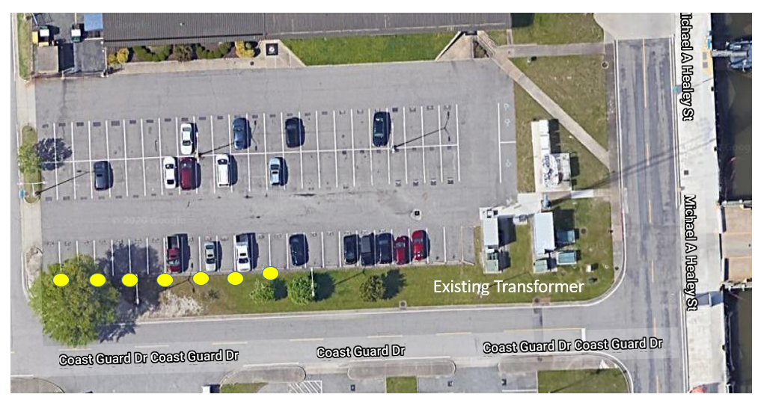

1.5 All work shall conform to relevant Federal, State, and regional codes and practices. Contractor must specifically follow NFPA 70: National Electrical Code, 2011, Chapter 6: Special Equipment, ARTICLE 625 Electric Vehicle Charging System.

1.6 Contractor shall obtain dig permits for all trenching or digging that occurs. Contractor shall locate all water, communication, power, fuel supply, natural gas, and other utilities within 10 feet of the proposed footprint.

1.7 Contractor shall consider construction best practices at Base Portsmouth to preserve standard aesthetic appearances. All impacted surfaces shall be restored to pre-construction conditions using like-kind materials.
11 13 36 Vehicle Charging Equipment

11.1 AC level 2 is defined in SAE Standard J1772 as wall or pedestal mounted charging infrastructure with cord set designed to use 208-V or 240-V AC input. Charging stations shall be pedestal mounted.

11.2 Charging units shall be certified by a nationally recognized testing laboratory and meet the following standards:
a. SAE Standard J1772
b. UL Standard for Electric Vehicle Charging System Equipment; UL2202
c. UL Standard for Plugs, Receptacles and Couplers for Electric Vehicles; UL2251
d. UL Standard for Personnel Protection Systems for Electric Vehicle Supply Circuits; UL2231
e. UL Standard for Enclosures for Electrical Equipment; UL50

11.3 Each level 2 charging station shall provide two SAE J1772 connectors and cord sets rated to provide 7.2 kWh. Connectors must be able to function simultaneously, i.e. charge two vehicles at once. Power and/or load share technology, which offers full power charging for one vehicle and split power when multiple vehicles are charging is not authorized under this contract.

11.4 All charger connection cables shall be a minimum of 15 feet.

11.5 Chargers must include visual operational status indicators to include at minimum: Ready to Charge, Charging, Complete, and Fault or equivalent and meet all data capability requirements as outlined on page 2 of this document.

11.6 Chargers shall have built-in electric nuisance tripping avoidance and auto-reclosure features.

11.7 Pedestal mounted charging stations shall include concrete foundations/charger pads with a top surface of consistent height. Minimum foundation/charger pad height is 2 inches above grade. All concrete used shall have a compressive strength of 2,500 PSI at 28 days. ACI 301 compliant forms shall be used for concrete placement. Chamfer above grade exposed joints, edges, and external corners of concrete 0.75 inch unless otherwise approved.

11.9 Protect all charging receptacles with vehicle parking stops and concrete bollards. Two bollards shall be installed at the front corners of each charging station pedestal. Contractor shall provide new parking stops for all spaces served by EVSE. Parking stop and bollard placement shall be in accordance with On-Site Representative guidance and Contracting Officer Representative’s approval.

11.9.1 Bollards must have a minimum height of 4 feet above finished grade. Bollards should be constructed of 4-inch diameter schedule 80 galvanized steel pipe filled with concrete, painted safety yellow, and set at least 4 feet below grade. Bolted bollards lack sufficient impact resistance and shall not be utilized.

11.10 Provide signage for each parking space supplied by a charger. Signs shall indicate “Electric Vehicle Parking Only” or equivalent. Sign design shall be approved by the On-Site Representative and Contracting Officer’s Representative prior to installation.

11.11 Cable holders and connector docks shall be provided with charging units to keep charge cords off the ground and neatly stored between uses.

11.12 All equipment, parts, and materials shall be appropriate or protected in such a way as to be appropriate for outdoor use and continuous exposure to temperatures, humidity, and marine air characteristic of the local climate. Charging units shall be rated to maintain consistent operations at ambient temperatures between 0 degrees F and 120 degrees F.

26 00 00 Electrical

26.1 The contractor shall evaluate electrical load capacity in accordance with provisions of the most recent National Electric Code. Construction shall commence only upon confirmation that existing infrastructure can support EVSE demand.

26.1.1 A submittal shall be provided for Contracting Officer’s Representative review documenting outcome of load evaluation. This submittal shall also include recommended electrical grid modifications necessary to support proposed charging stations. No transformer or panel installations may occur prior to submittal acceptance.

26.1.2 The existing transformer is a 480-V transformer. Contractor is responsible for all design, procurement, fabrication, site assessment, site preparation, construction, testing, and any other work necessary for the proper installation and commissioning of a step-down transformer suitable to support seven (7) 208-V/240-V charging stations and all associated electrical equipment.

26.1.3 The contractor shall install an independent sub-meter upstream of all EVSE that complies with local, state and national codes. Sub-meter shall be capable of capturing and reporting total EVSE energy consumption independent of adjacent facility and equipment loads. Electricity consumed by EVSE shall be metered independently of other utilities consumed at Base Portsmouth.

26.1.4 Should electrical upgrades beyond those included in the contractor’s original proposal prove necessary, the Coast Guard may reduce the total number of pedestals to be installed to offset electrical upgrade costs.

26.2 Design electric installations in accordance with local standard voltages and distribution standards. Charging stations shall be installed on a dedicated, sub-metered circuit with a 2-pole, 40 A, 208-240 V AC, 60 Hz, non-GFCI circuit breaker. Level 2 charging units have built in GFCI protection; no additional GFCI protection upstream of the charging unit should be installed.

26.3 Electrical wires shall be routed through an approved conduit or jacket from the circuit panel to the charging unit or receptacle. Electrical conduits shall be buried for any runs that cannot be mounted. Where conduit traverses paved surfaces, either boring or saw cutting is permissible. All surfaces damaged during construction shall be restored to pre-construction conditions using like-kind materials.

VIII: Construction Submittal Register:

The following submittals shall be provided for charging station construction at each unit.

Submittal Title | Submitted | Returned | Status
Superintendent Resume and Designation
Safety Plan
Employee Register
Charging Station Equipment Cut Sheets
Electrical Equipment Cut Sheets
Electrical Load Evaluation and Panel Assessment
Parking Signage
Raised Footing, Bollard, or Vehicle Parking Stop Proposed Layout and Cut Sheets
Construction Schedule
Construction Cost Breakdown

